### 

### Semester Two Examination, 2018

### Question/Answer booklet

# MATHEMATICS METHODS

**UNIT 1 AND 2**

## Section One:

## Calculator-free

Name: _______________________________________________________

Teacher’s Name:_______________________________________________

## Time allowed for this section

Reading time before commencing work: five minutes

Working time: fifty minutes

## Materials required/recommended for this section

***To be provided by the supervisor***

This Question/Answer booklet

Formula sheet

***To be provided by the candidate***

Standard items: pens (blue/black preferred), pencils (including coloured), sharpener, correction fluid/tape, eraser, ruler, highlighters

Special items: nil

## Important note to candidates

No other items may be taken into the examination room. It is **your** responsibility to ensure that you do not have any unauthorised material. If you have any unauthorised material with you, hand it to the supervisor **before** reading any further.

|  |  |
| --- | --- |
| **Question** | **Mark** |
| **1** |  |
| **2** |  |
| **3** |  |
| **4** |  |
| **5** |  |
| **6** |  |
|  |  |
| **TOTAL** |  |

**Structure of this paper**

|  |  |  |  |  |  |
| --- | --- | --- | --- | --- | --- |
| Section | Number of questions available | Number of questions to be answered | Working time (minutes) | Marks available | Percentage of examination |
| Section One:  Calculator-free | 6 | 6 | 50 | 50 | 33 |
| Section Two:  Calculator-assumed | 9 | 9 | 100 | 100 | 67 |
|  |  |  |  | **Total** | 100 |

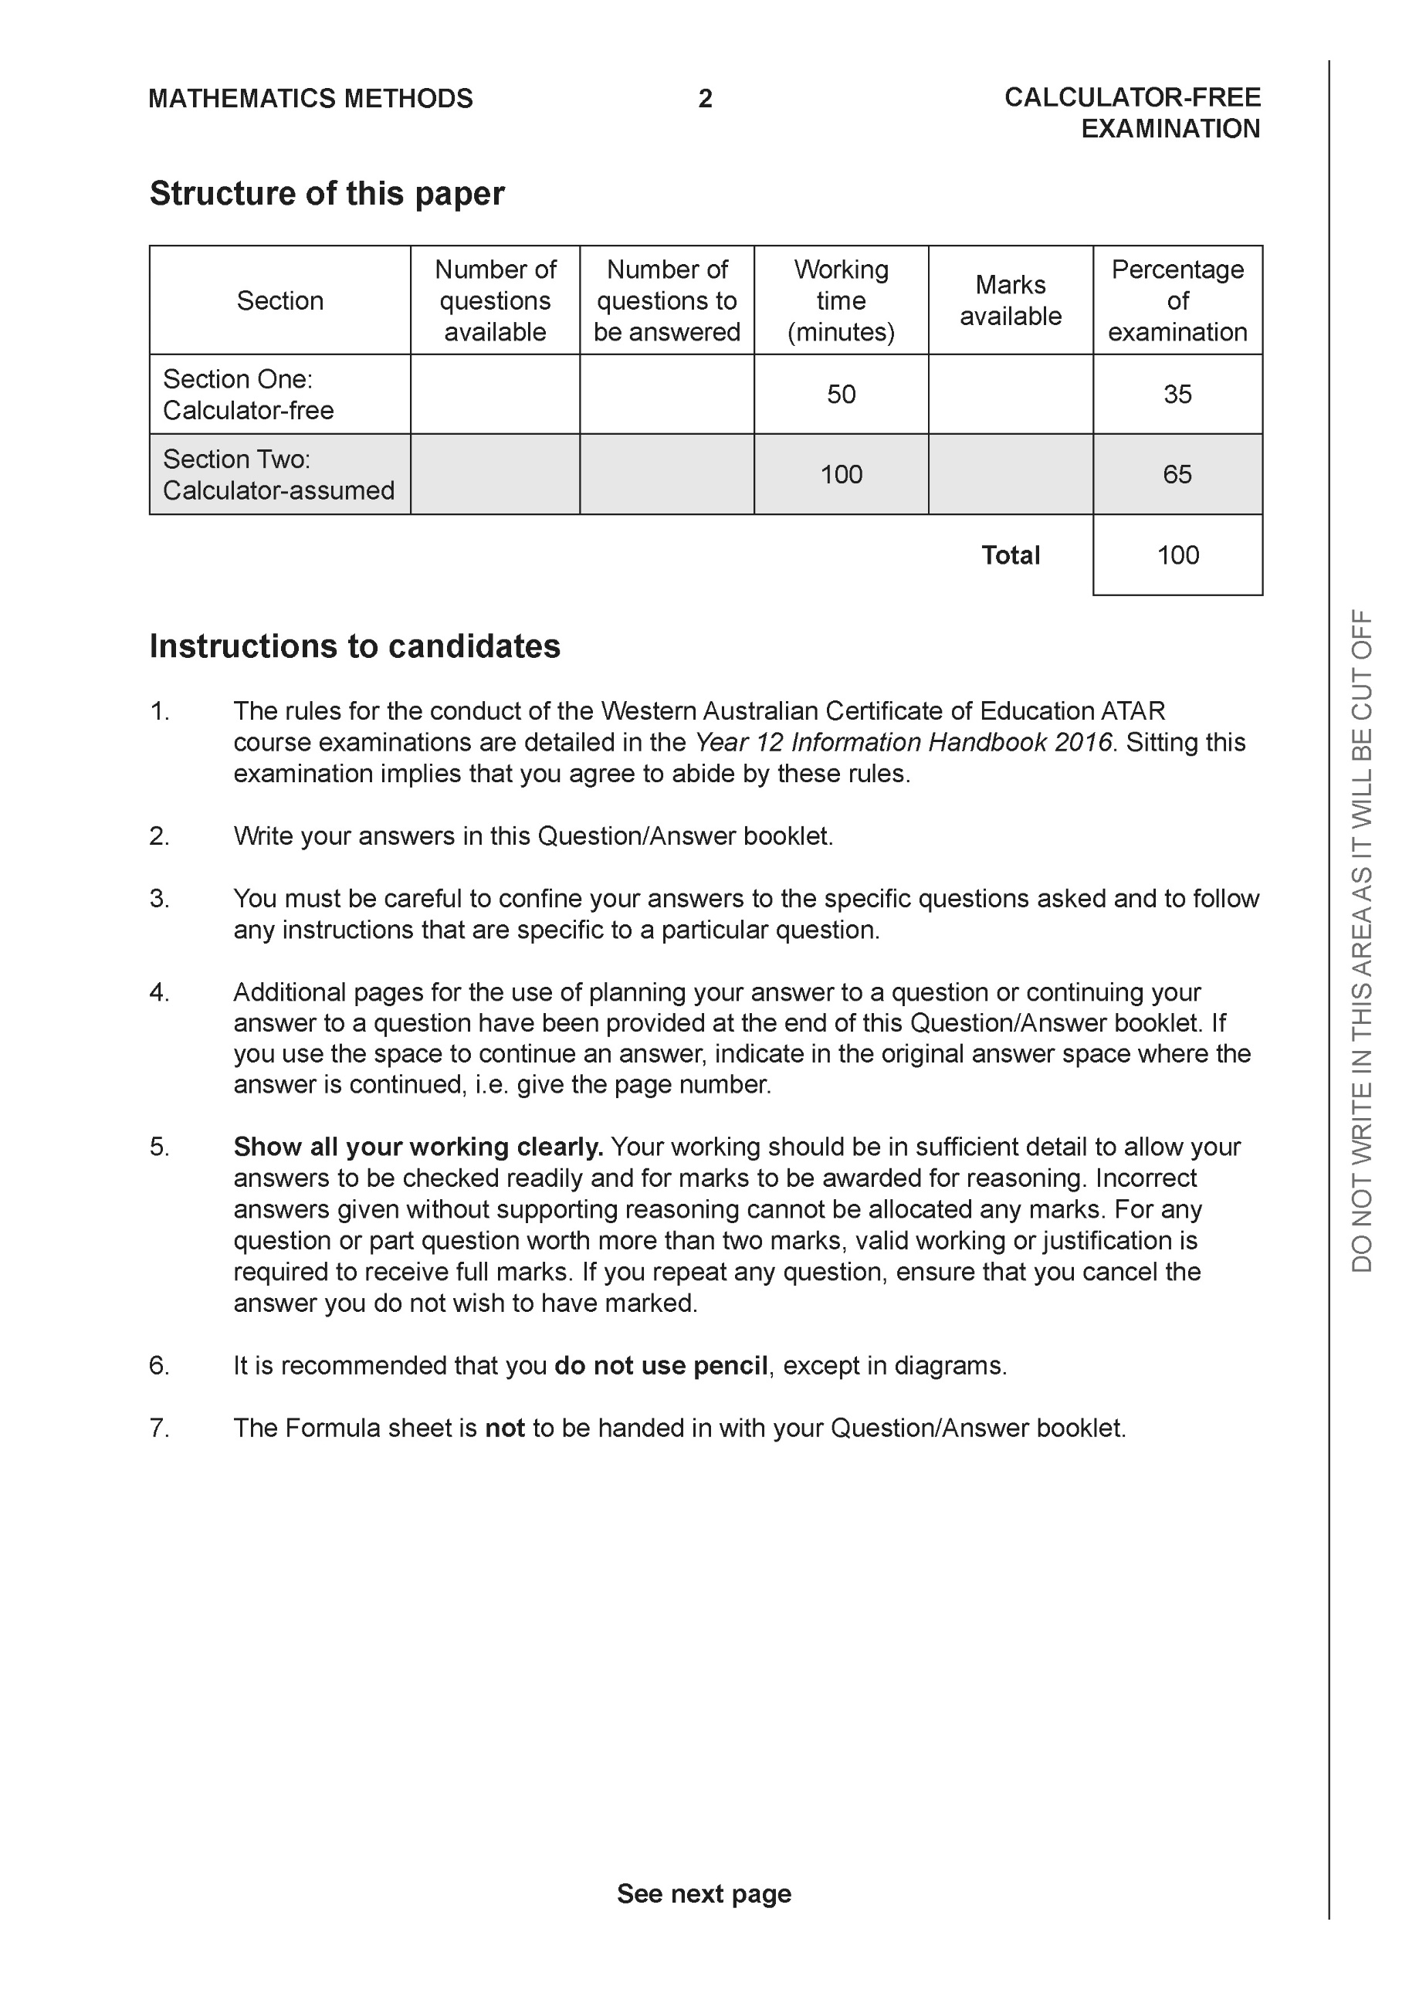

**Section One: Calculator-free (50 Marks)**

This section has **six (6)** questions. Answer **all** questions. Write your answers in the spaces provided.

Spare pages are included at the end of this booklet. They can be used for planning your responses and/or as additional space if required to continue an answer.

● Planning: If you use the spare pages for planning, indicate this clearly at the top of the page.

● Continuing an answer: If you need to use the space to continue an answer, indicate in the original answer space where the answer is continued, i.e. give the page number. Fill in the number of the question that you are continuing to answer at the top of the page.

Working time: 50 minutes.

**A close up of a logo

Description generated with high confidenceQuestion 1 ( 5 marks)**

The roof of a heritage building has roof tiles arranged neatly in horizontal rows. A sample diagram is shown below.

There are 28 roof tiles in the top row and each consecutive row has an extra 4 tiles than the row above it. If the bottom row has 96 tiles, show that there is a total of 1116 tiles on the roof of the museum.

|  |
| --- |
| **Solution** |
| There are 18 rows of tiles, and a total of 1 116 tiles on the roof. |
| ✔ identifying important info  ✔ setting up equation to find  ✔ the value of  ✔ setting up equation to find  ✔ showing that there are 1 116 tiles |

**Question 2 ( 5 marks)**

Evaluate the expression below, giving your answer as a simplified fraction.

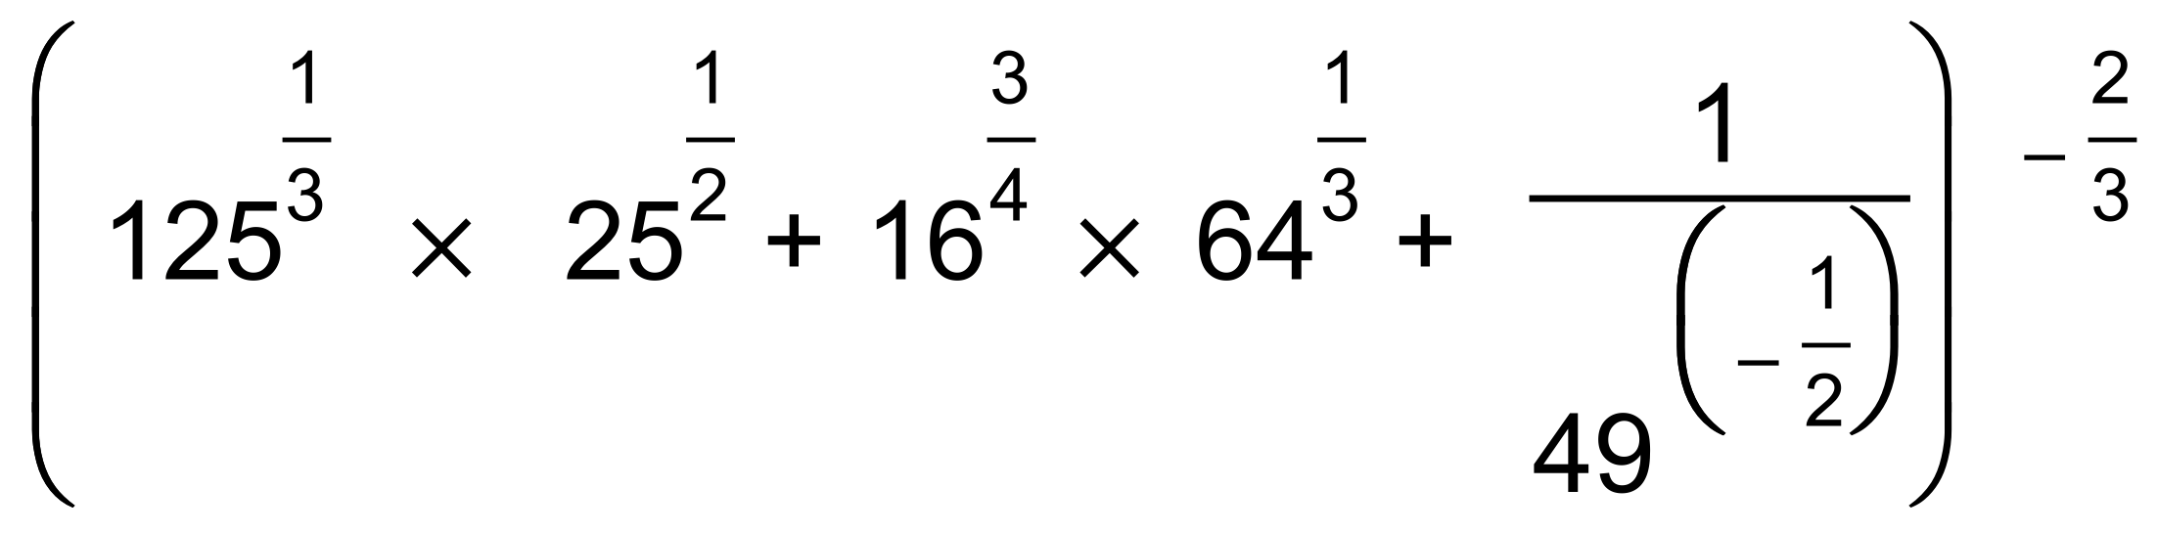

|  |
| --- |
| **Solution** |
|  |
| ✔✔ evaluating indices  ✔applying BIMDAS  ✔evaluated/simplified fraction |

**Question 3 (11 marks)**

Given the function

(a) state . Do not simplify. (2 marks)

|  |
| --- |
| **Solution** |
|  |
| ✔✔ (-✔ for every wrong term) |

(b) set up and evaluate the difference quotient to find the derivative of the function.

(4 marks)

|  |
| --- |
| **Solution** |
|  |
| ✔ setting up difference quotient with limit notation  ✔ expanding  ✔ cancelling terms  ✔ derivative |

(c) What is the instantaneous rate of change when (2 marks)

|  |
| --- |
| **Solution** |
|  |
|  |

(d) Is the rate of change increasing or decreasing for Justify. (3 marks)

|  |
| --- |
| **Solution** |
| Stationary point is when      Stationary point is when  Taking a point to the left of  .  Hence, the rate of change is decreasing for |
| ✔ determining stationary points  ✔ rate of change increasing  ✔ valid justification |

**Question 4 ( 7 marks)**

Given the equation

(a) use a suitable substitution to rewrite the equation above as a quadratic equation,

(3 marks)

|  |
| --- |
| **Solution** |
|  |
| ✔ using appropriate substitution  ✔✔ quadratic equation (**-**✔ for every wrong term) |

(b) hence, determine the solution(s) to the exponential equation. (4 marks)

|  |
| --- |
| **Solution** |
|  |
| ✔ factorising quadratic  ✔ y values  ✔✔ for solutions to the exponential equation |

**Question 5 (11 marks)**

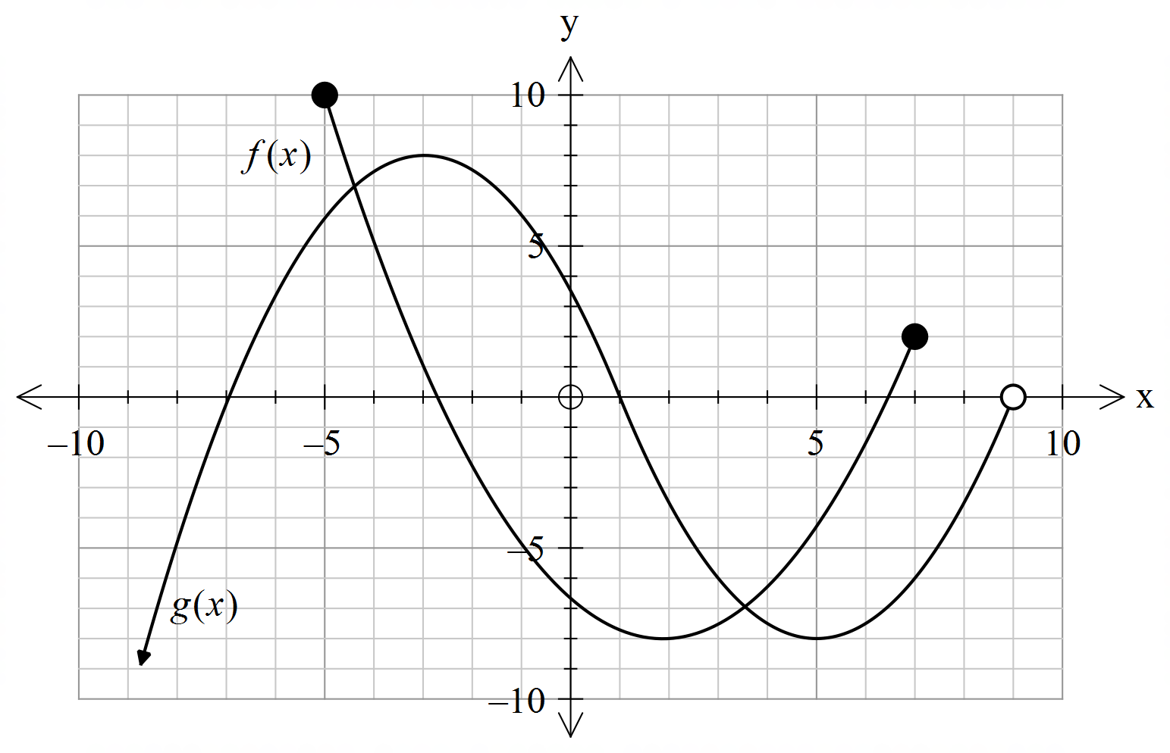The graphs of the functions  and  are shown below.



(a) State the domain of . (1 mark)

|  |
| --- |
| **Solution** |
|  |
|  |

(b) State the range of . (1 mark)

|  |
| --- |
| **Solution** |
|  |
|  |

(c) Which function(s), if any, have a point of inflection? (1 mark)

|  |
| --- |
| **Solution** |
|  |
|  |

(d) Describe how the graph of  may be obtained from the graph of  and hence state the coordinates of the turning point(s) of the graph. (3 marks)

|  |
| --- |
| **Solution** |
| Reflection about the x axis.  Turning points: and |
| ✔ identifying transformation  ✔✔ correct turning points |

(e) Describe how the graph of  may be obtained from the graph of  and hence state the coordinates of the endpoints of the graph. (3 marks)

|  |
| --- |
| **Solution** |
| Horizontal translation of 1 unit to the left.  End points: and |
| ✔ identifying transformation  ✔✔ correct end points |

(f) State the approximate solution(s) to the equation . (2 marks)

|  |
| --- |
| **Solution** |
|  |
|  |

**Question 6 (12 marks)**

Given the following equations:

1. Sketch on a single set of axes the graph of and . (4 marks)

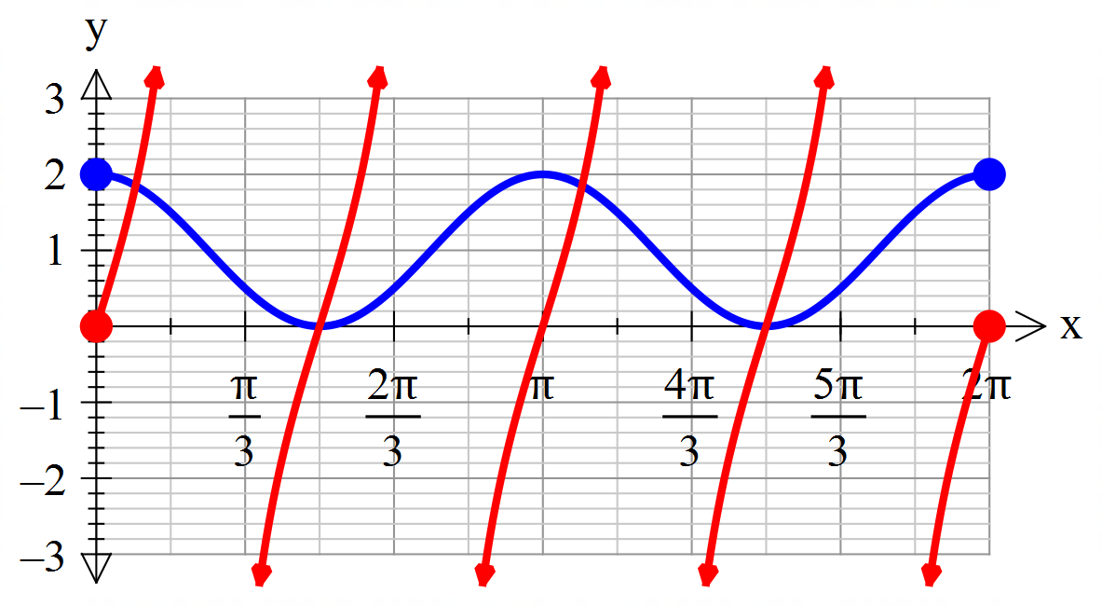

|  |
| --- |
| **Solution** |
| See graph above. |
| For each function:  ✔ shape  ✔ accuracy |

(b) Show that the coordinates of the points of intersection between the graphs of and are solutions of the equation (4 marks)

|  |
| --- |
| **Solution** |
|  |
| ✔ rewriting tan in terms of sin and cos  ✔ multiplying both sides by cos  ✔ using Pythagorean identity  ✔ required equation |

(c) Hence find the coordinates of the points of intersection between the graphs of and

over the domain . (4 marks)

|  |
| --- |
| **Solution** |
|  |
| ✔ factorizing quadratic and finding two solutions  ✔ indicating that there are no solutions for  ✔ ✔ finding the 4 solutions (-✔ for every incorrect answer) |

**END OF SECTION 1**

Additional working space

Question number:

Additional working space

Question number:

Additional working space

Question number:

Additional working space

Question number: